Emerging Software Engineering Principles

Project Sprint 1 Submission

John Foster, Clifton Malecki, Vladmir Maximov, Koko Afantchao

GitHub URL: <https://github.com/jtfoster2/Outdora>

Story Point Forecast: Approximately 16 points, expecting 1 hour of work per point, detailed here: <https://github.com/jtfoster2/Outdora?tab=readme-ov-file#project-kanban-board>

GitHub Projects Board URL: <https://github.com/users/jtfoster2/projects/1/views/1>

Stories are broken down into tasks using checkboxes in the issue description: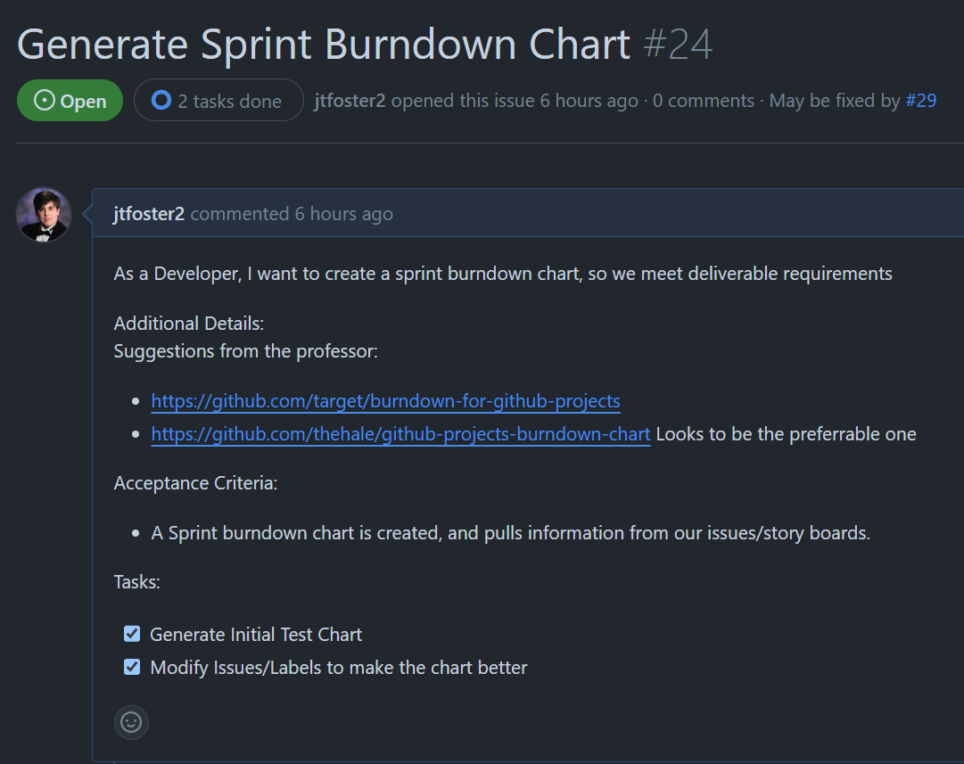

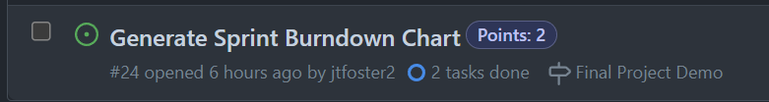

Sprint Burndown Chart: <https://github.com/jtfoster2/Outdora/blob/main/docs/burndown_charts/ESEP_Burndown_Chart_Sprint_1.png>

Implemented a Burndown Chart created by Joseph Hale: <https://github.com/thehale/github-projects-burndown-chart>

GitHub Projects doesn’t have a free burndown chart, so I had to use this program to generate it, apologies for any oddities from its limitations.

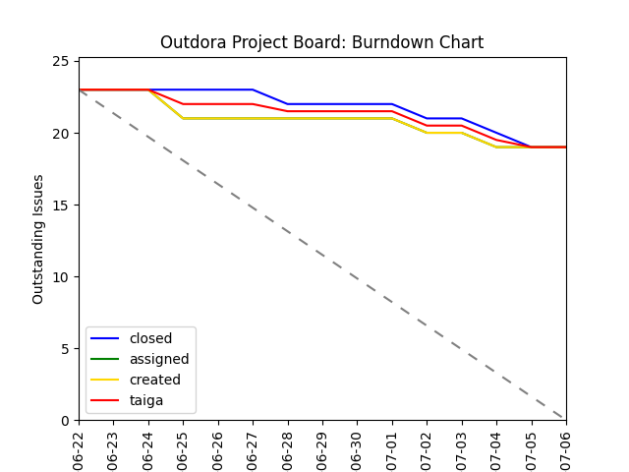

Scrum Transcripts: <https://github.com/jtfoster2/Outdora/tree/main/docs/scrum_transcripts/sprint1>

Pair Programming: <https://github.com/jtfoster2/Outdora/blob/main/docs/collaborations/PairProgrammingLinks.md>

Sprint Review: <https://github.com/jtfoster2/Outdora/blob/main/docs/sprint_reviews/SprintReviewLinks.md>

Release: Project is currently built into a docker image that can be run locally on localhost:8080, as an artifact in individual action runs: <https://github.com/jtfoster2/Outdora/actions>, or in releases at the end of the sprint <https://github.com/jtfoster2/Outdora/releases>